## Information Literacy Exit Survey

## Question 1

On a scale of 1-5: *How would you describe your level of confidence in discovering, evaluating, and incorporating information sources* ***before*** *completing your information literacy work in this course?*

*How would you describe your level of confidence* ***af****ter?*

## Question 2 Chart

*Which of the information literacy activities/assignments do you feel helped you learn information literacy concepts, if any?*

*What made these assignments helpful?*

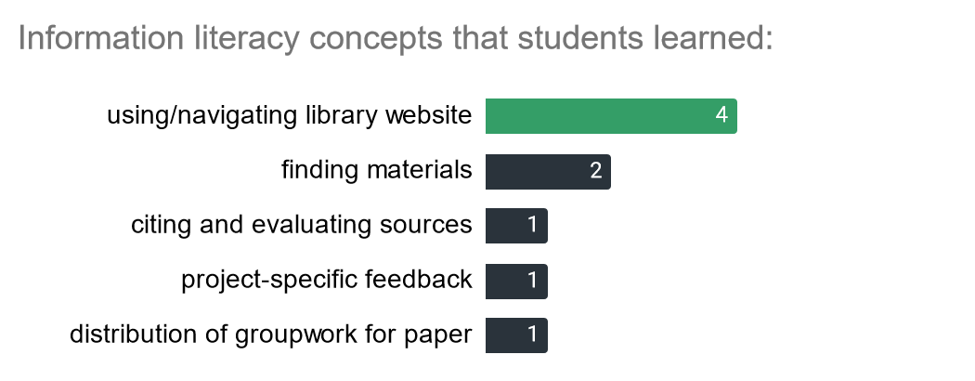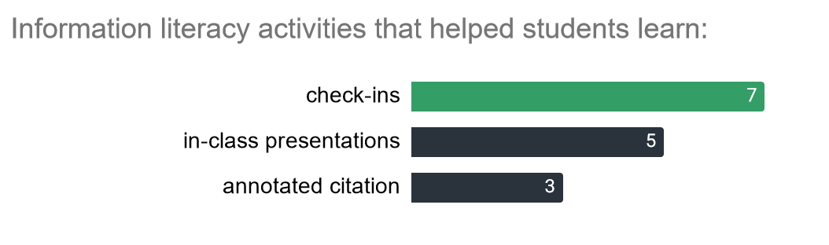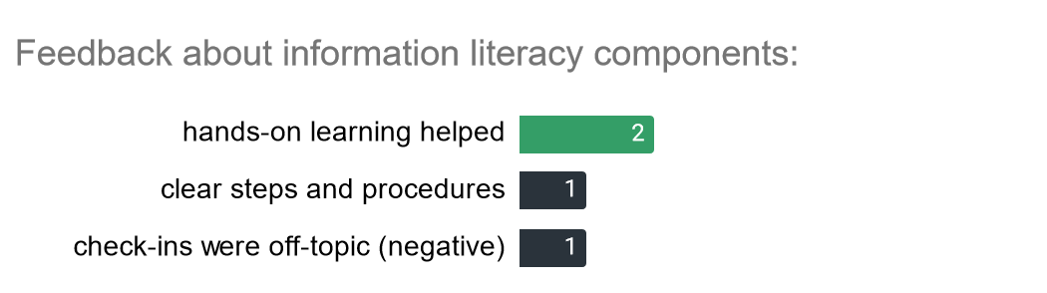

## Question 3

*What was the most valuable thing you learned from working with the librarians who partnered with your course instructor?*

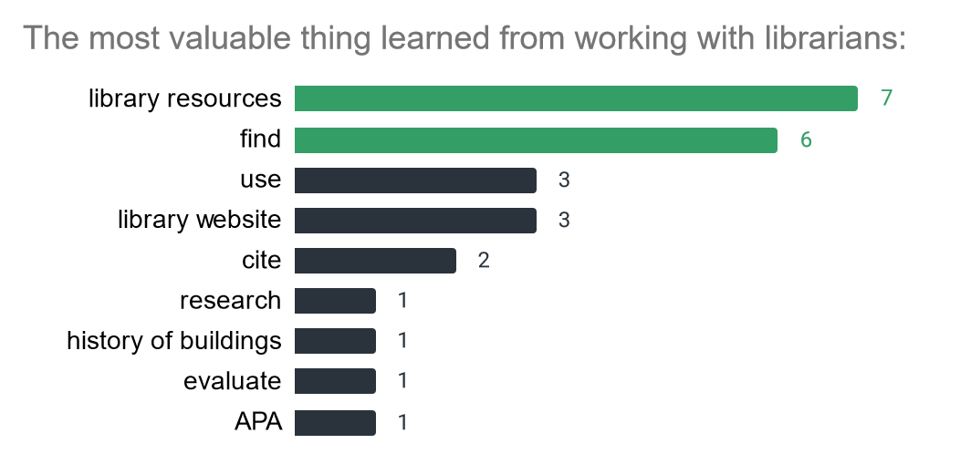

## Question 4

Take some time to reflect on the information literacy skills you learned in this class.

*How do you think they might help you in future academic settings (for example other classes or graduate-level education)?*

*How do you think they might help you in your non-academic life, both personal and professional?*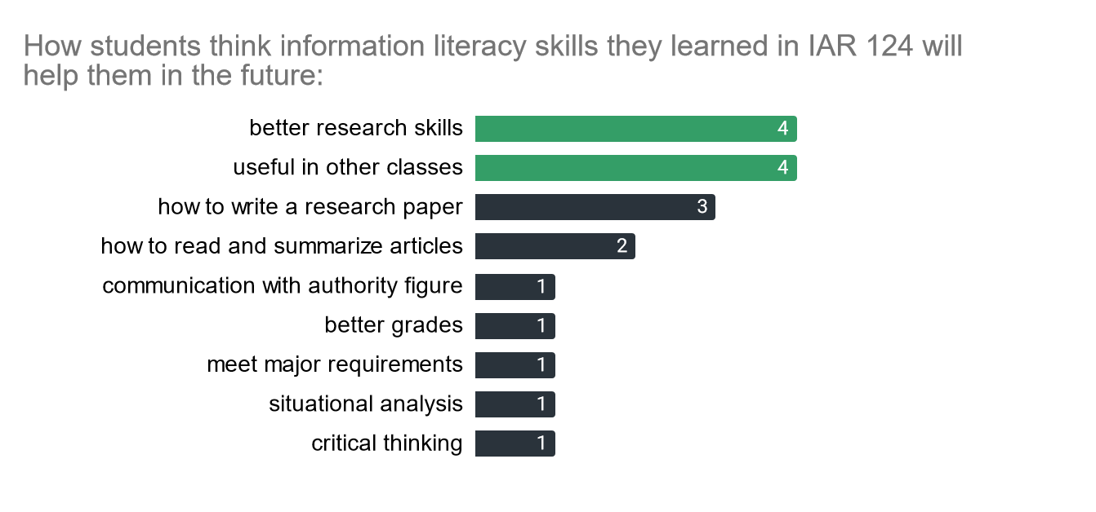

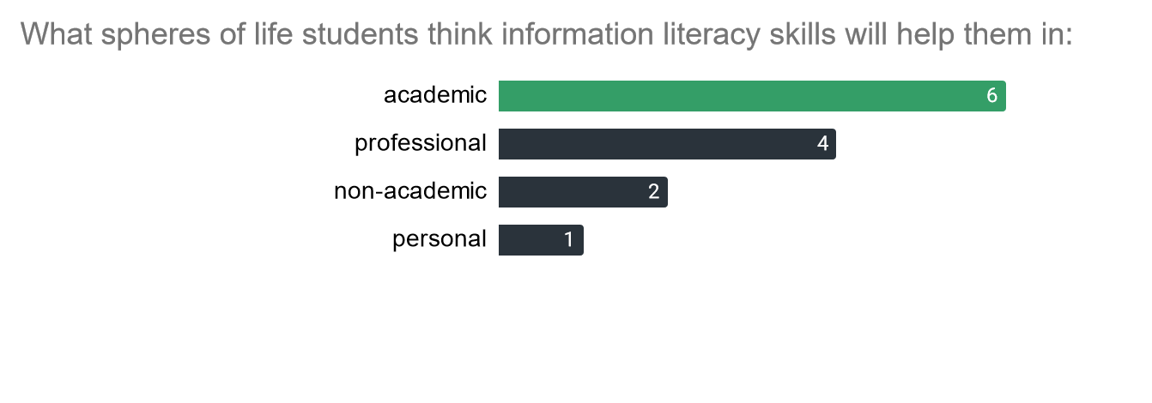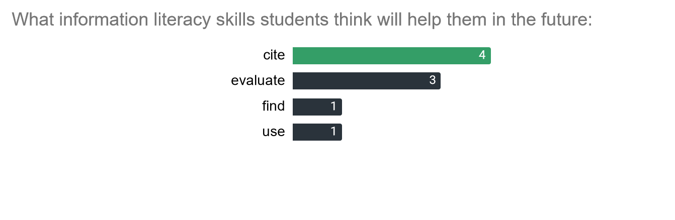

## Question 5

Our class also addressed other types of literacy through a coordinated sequence of activities. First, you were introduced to the concept of building conservation as a key sustainable design strategy. Then our course partner Kathelene Smith gave a presentation on the history of the UNCG campus. Finally, we went on a tour of historic campus buildings with the UNCG University Archives staff.

*Can you comment on how these activities, and in particular, the campus tour, contributed to your understanding of building conservation, UNCG history, and sustainable design at large--if at all?*

